project management Plan

for

Car Purchasing WEB App

V 1.1

VERSION HISTORY

|  |  |  |  |  |  |
| --- | --- | --- | --- | --- | --- |
| **Version** | **Implemented By** | **Revision Date** | **Approved By** | **Approval Date** | **Reason** |
| **1.0** | **Beshoy Sameh**  **Aml Mostafa** | **20/02/2023** | **Menna abdelmjeed**  **Salma gamal** | **21/02/2023** | **Initial Version** |
| **1.1** | **Beshoy Sameh** | **23/2/2023** | **Aml Mostafa** | **23/2/2023** | **Added RTM** |
| **1.2** | **Aml Mostafa** | **10/3/2023** | **Beshosy Sameh** | **10/3/2023** | -**Goal part and validation strategy**  **-RACI in Roles and responsibilities**  **-Out of Scope part**  **-Github Structure**  **-CIL** |
| **1.3** | **Aml Mostafa** | **13/3/2023** | **Beshosy Sameh** | **17/3/2023** | **-added Baseline strategy** |
|  |  |  |  |  |  |
|  |  |  |  |  |  |
|  |  |  |  |  |  |
|  |  |  |  |  |  |

Contents

1. Introduction 3

1.1 Goal 3

1.2 Purpose of project management plan 3

1.3 Timeline 3

I. Team 3

**1.4** **Assumptions and Constraints** 3

I. Assumptions: 3

II. Constraints: 3

**1.5** **Scope Management** 4

I. In Scope: 4

II. Out of Scope: 4

2. Schedule / Time Management 4

2.1 Milestones 5

2.2 Project Schedule 6

2.3 Project Life Cycle 6

2.4 Roles and Responsibilities 7

3. Configuration Management 7

4. Validation Strategy 8

5. Communication Management 8

I. Communication goals: 8

6. Risk Management 8

7. REVIEW PROCESS 8

8. CIL 9

9. Baseline Statrategy……………………………………………………………………………………………………………………………………………………10

# 

# Introduction

## Goal

Develop a website to help the user to buy their car from an enormous data.

## Purpose of project management plan

All project stakeholders, including the project sponsor, senior leadership, and the project team, are the target audience for the car purchasing PMP.

## Timeline

We plan to provide Five milestones for the project and define the project as ready for publishing within 5 weeks. (5 Engineers each work daily for 2 hours)

### Team

Our team consists of 5 members as follow:

1. Aml Mostafa ( Team Leader )
2. Beshoy Sameh (developer and tester )
3. Menna Abdelmjeed ( developer and tester )
4. Salam Gamal ( developer and tester )
5. Ahmed Fouda ( developer and tester )

## **Assumptions and Constraints**

### Assumptions:

* Search engine includes searching by Car brand and price.
* A button for adding cars is added to enable sellers to market and submit info about the cars they want to sell.
* Admin can approve and decline car addition, deletion and reservation.

### Constraints:

* Should use Web based System.
* Should obtain Unique user IDs
* Admin features.

## **Scope Management**

### In Scope:

* The scope of this project includes design, implementation and testing of the features described in the succeeding sections of this document.
* Functional testing & external interfaces.
* PMP
* Validation testing

### Out of Scope:

* Non-functional testing like stress, performance
* Unit and automation testing
* Integration testing
* Verification

# Schedule / Time Management

## Milestones

|  |  |
| --- | --- |
| **Milestones** | **Estimated Completion Timeframe** |
| **Requirements**   * SRS * SIQ * PMP * Configuration Management Setup * Project Schedule * CIL | **2 Weeks**  **from** 18/2/2023  **to** 10/3/2023 |
| **Diagrams** | **1 Week**  **from** 11/3/2023  **to** 17/3/2023 |
| **Implementation** | **1 Week**  **from** 17/3/2023  **to** 24/3/2023 |
| **Testing** | **1 Week**  **from** 25/3/2023  **to** 31/3/2023 |
| **Releasing** | **1 Week**  **from** 31/3/2023  **to** 15/3/2023 |

## Project Schedule

https://trello.com/b/oUZEmBcZ/car-purchasing-app

## Project Life Cycle

We are following the Waterfall Model of SDLC

(But we are also using some Agile methodologies in reviewing and daily meetings)

Each step depends on the previous step (Finish to Start)

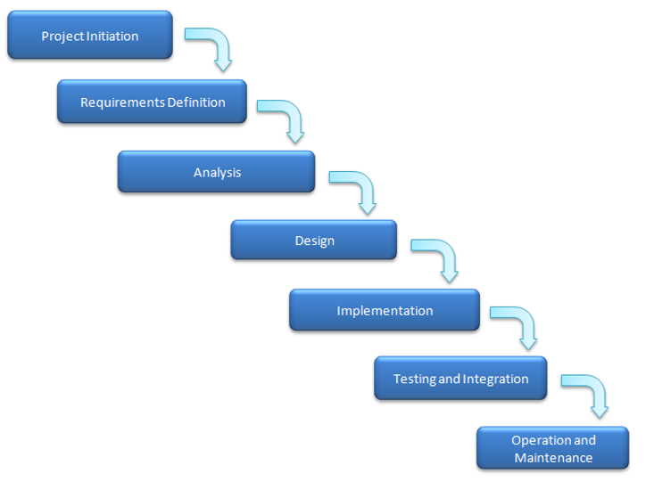

## 2.4 Roles and Responsibilities

## https://docs.google.com/spreadsheets/d/1QhFv5anO7qgv1mIVU_Q9anTqwQSyWzSV0b6wMtWODdc/edit#gid=0

# Configuration Management

We tailored our Configuration Management tool to use GitHub

The guidelines on how we will use the CM:

|  |  |
| --- | --- |
|  |  |

* Pull requests are required for the master branch only.

* Folder Structure:

Readme File is provided to help identifying the location of each file in the below Link:

<https://github.com/beshoysamehsamaan/Car-Purchasing-App>

# Validation Strategy

* 1. **Test Type**

Manual Testing

* 1. **Test levels**

System Test

* 1. **Test Techniques**

Black Box

Functional

# Communication Management

**Communication plan**

### Communication goals:

* keep the project progress up to date
* Provide a detailed explanation of any decisions or obstacles that must be made.
* Establish opportunities for project manager to provide feedback.

**Project Teams' communication:**

* An offline meeting is held every Saturday
* Online meetings are held throughout the week between team members to track the project’s progress

Using google meet

# Risk Management

External Risk Management File in the below Link:

https://docs.google.com/spreadsheets/d/1q2UabJpgOshgvWdXje7CKxYZBk8tXu1p6yCmoZUQL8U/edit#gid=0

# REVIEW PROCESS

We maintain that every work product is well reviewed by the right team members through review check lists and comments

# CIL

chrome-extension://gbkeegbaiigmenfmjfclcdgdpimamgkj/views/app.html

# Baseline Strategy

The Learning Hub Project schedule will be updated weekly after each baseline. The main milestones of the project will be the weekly deliverables’ submission during the weekly meeting with the customer. The project baseline will be determined at each submission of a version of the Learning Hub website.